General Collection
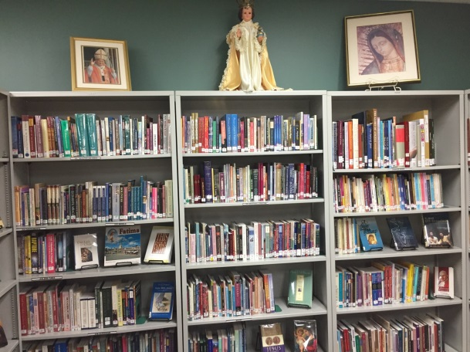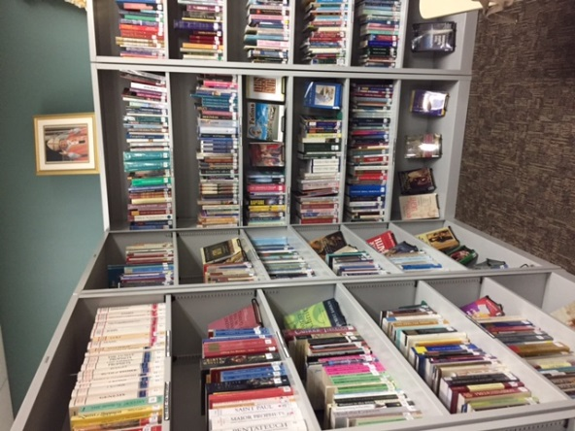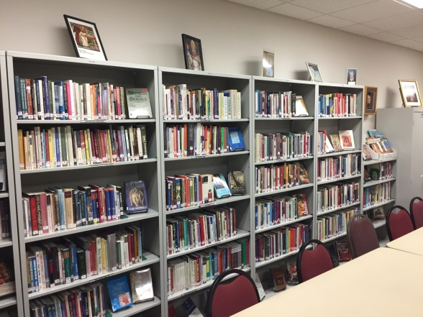
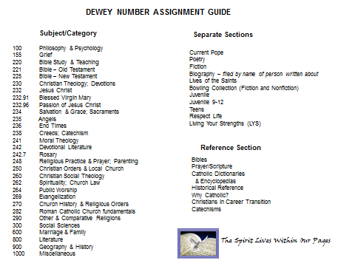
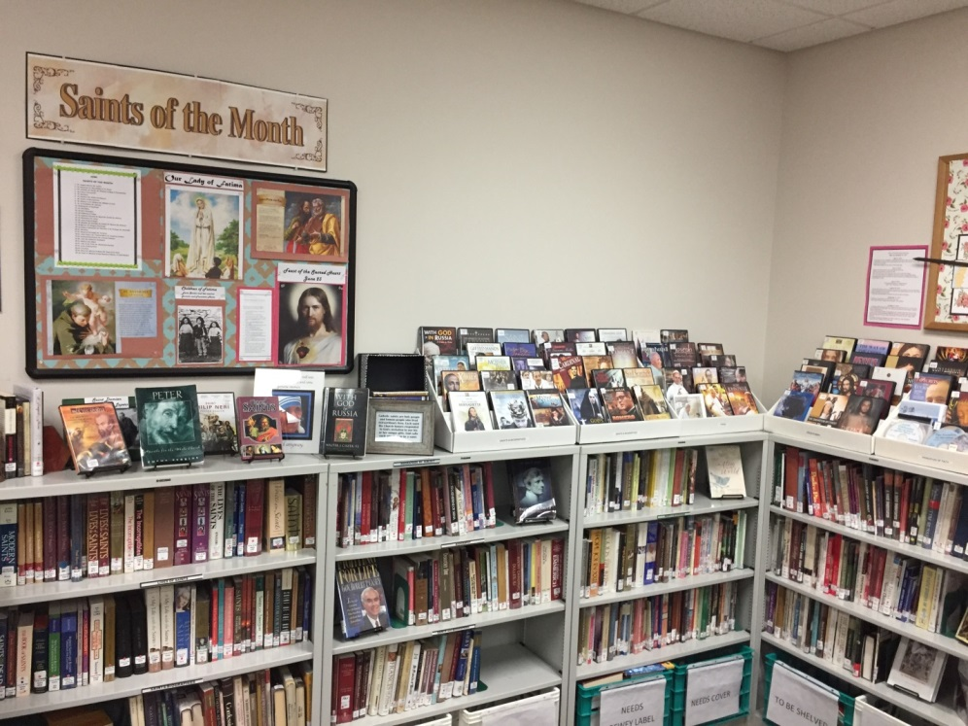
Saints, Biographies, Fiction, Living Popes, Poetry, Media
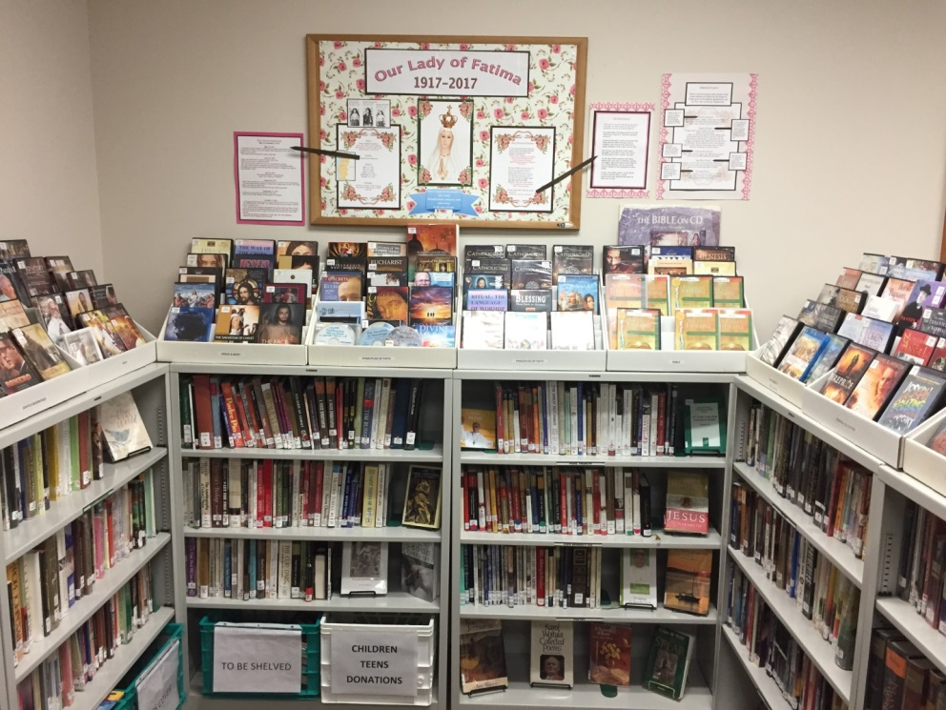
“Reading the lives of the saints is a great means to preserve piety.”
--St. Philip Neri

Juvenile
Children will enjoy browsing this section of the library to find books, CDs, and DVDs about
Jesus, Mary, Saints, Bible Stories, Sacraments, Prayer, Character Building
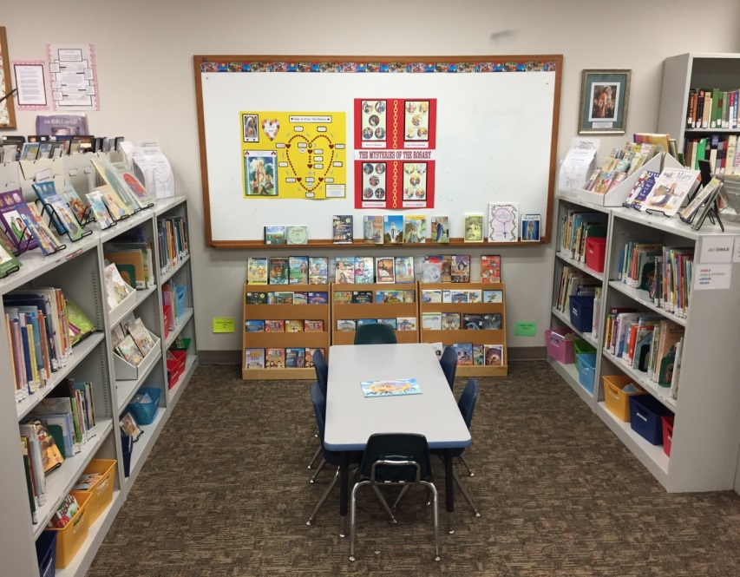
Juvenile 9-12 years of age
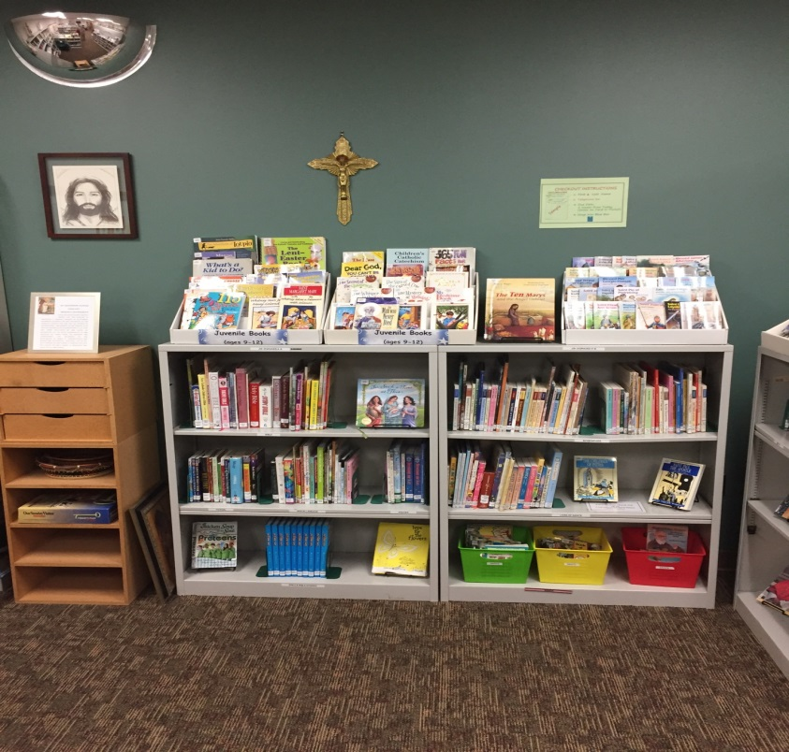

Teens
Our Teen Section provides books and media on the following topics:
Bible, Catechism, Faith, Fiction, Nonfiction,
Saints and Biographies, Spirituality

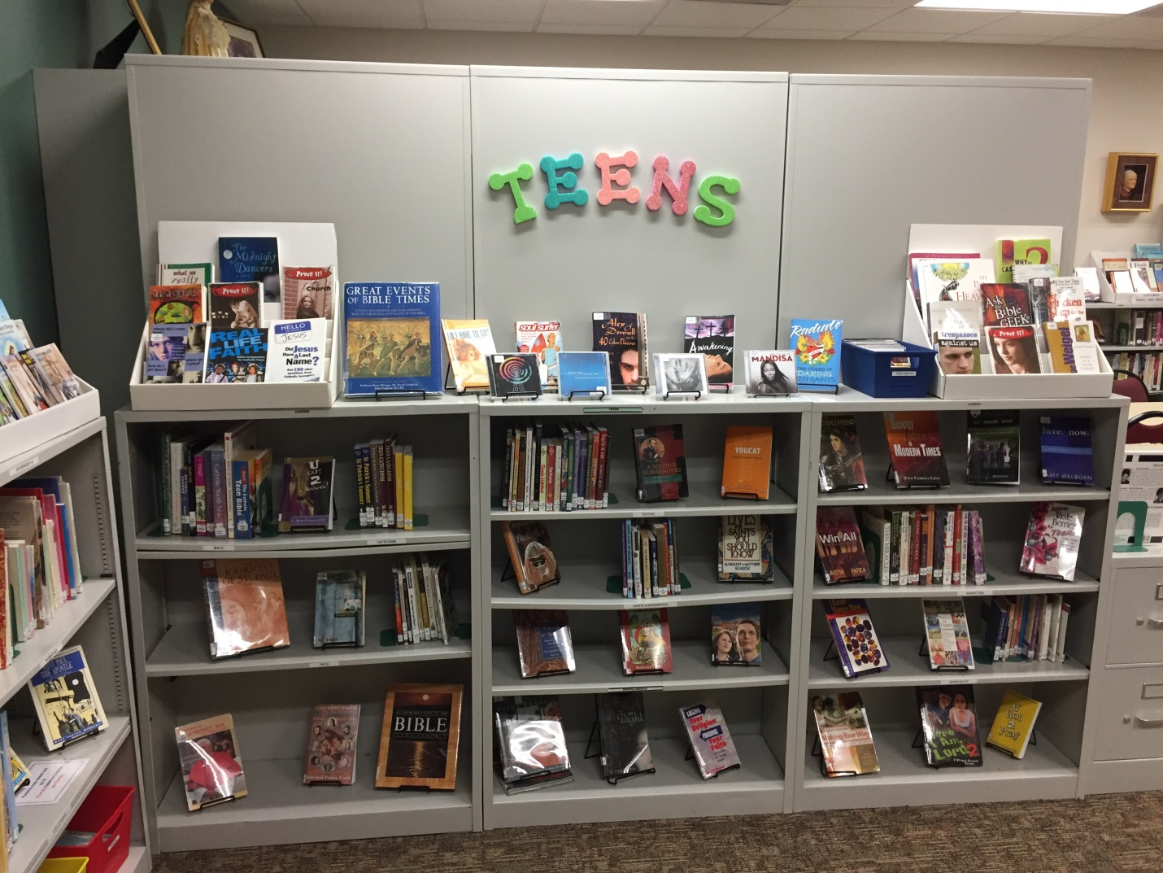

“Only God knows the good that can come about by reading one good Catholic book.”
--St. John Bosco

Bowling Collection and Reference Section
Through the generosity of Charles B. Bowling, Jr. and his family, the seeds of your St. Matthew Parish Library were planted. The collection of books located near the Reference Section represents Mr. Bowling’s personal library, which was donated to the parish in his memory. Without that donation this parish library might never have come to fruition. Many thanks to the Bowling Family for providing the impetus from which this library grew.

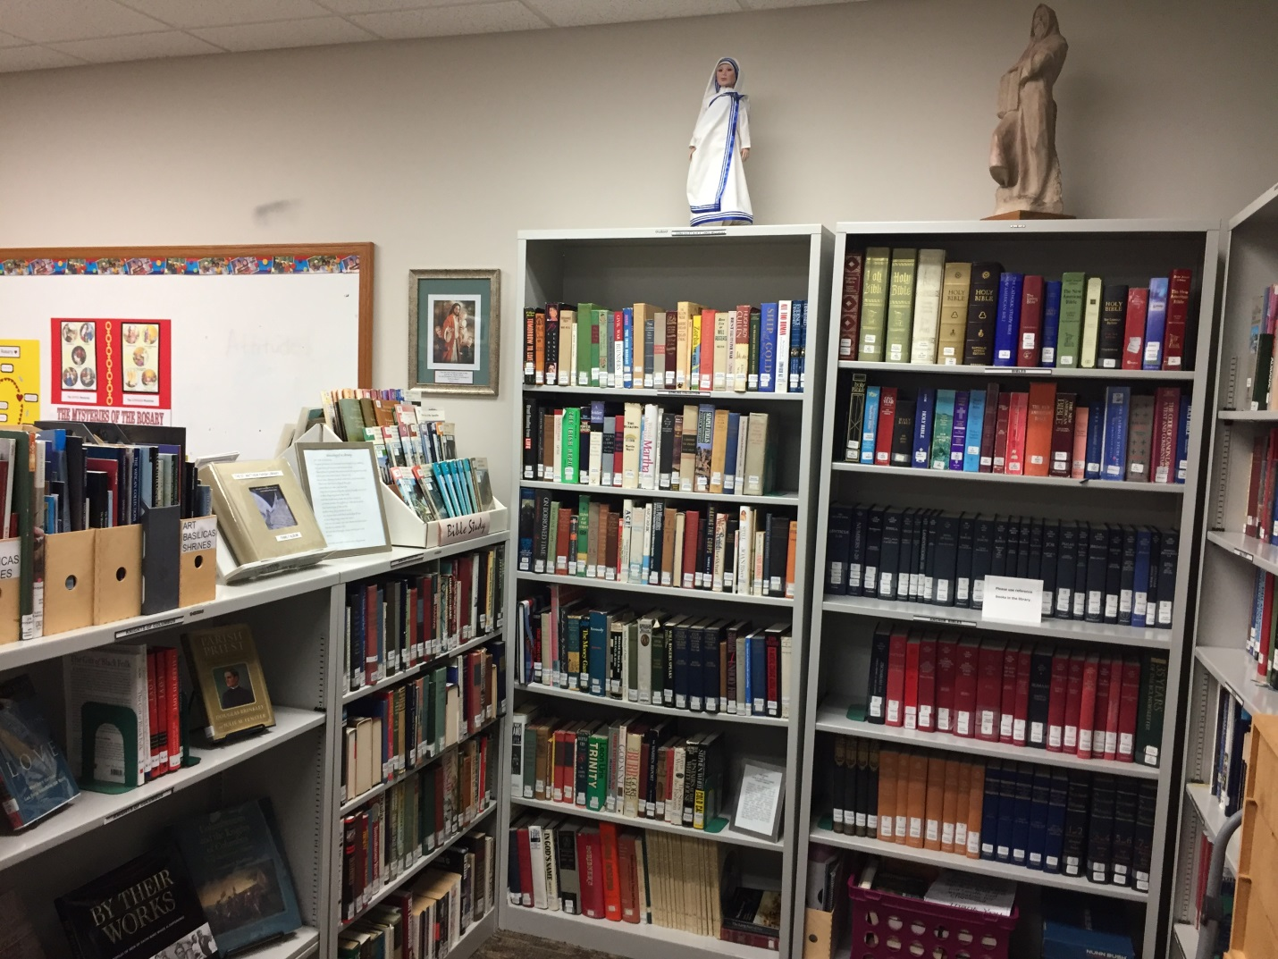
“It is our duty to live among books; especially to live by one book, and a very old one.”
--Blessed John Henry Newman

