**FAVORITES**

**St. Matthew Parish Library – Recommended Viewing**

Veggie Tales: Lettuce Love One Another

by Big Idea Productions

**Available in the parish library – NLC 102**

**St. Matthew Parish Library – Recommended Reading**

Princess Joy’s Birthday Blessing by Jeanna Young & Jacqueline K. Johnson

**Available in the parish library – NLC 102**

**St. Matthew Parish Library – Recommended Reading**

Dear Pope Francis: The Pope Answers Letters from Children Around the World

by Pope Francis

**Available in the parish library – NLC 102**

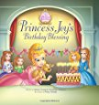

[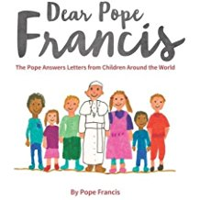](https://www.amazon.com/Dear-Pope-Francis-Answers-Children/dp/0232532648/ref=sr_1_2?ie=UTF8&qid=1489845207&sr=8-2&keywords=dear+pope+francis)

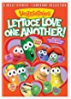

**St. Matthew Parish Library – Recommended Reading**

Mother Teresa of Calcutta by Francine Bay & Emmanuel Beaudesson

**Available in the parish library – NLC 102**

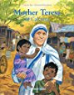

**St. Matthew Parish Library – Recommended Reading**

Bernadette: The Little Girl from Lourdes by Sophie Maraval-Hutin

**Available in the Juvenile Section of the parish library – NLC 102**

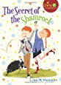

**St. Matthew Parish Library – Recommended Viewing**

Brother Francis: Forgiven

DVD for Children

**Available in the Juvenile Section of the parish library – NLC 102**

**St. Matthew Parish Library – Recommended Reading**

Roses in the Snow: A Tale of Saint Elizabeth of Hungary by Dessi Jackson

**Available in the Juvenile Section of the parish library – NLC 102**

**St. Matthew Parish Library – Recommended Reading**

The Secret of the Shamrock by Lisa Hendey

**Available in the Juvenile (9-12) Section of the parish library – NLC 102**

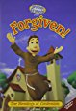

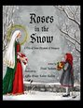

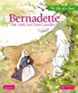

**St. Matthew Parish Library – Recommended Reading**

TREASON: A Catholic Novel of Elizabethan England by Dena Hunt

**Available in the parish library – NLC 102**

[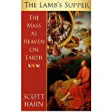](https://www.amazon.com/Lambs-Supper-Heaven-Paperback-Common/dp/B00FGVY8G0/ref=sr_1_3?s=books&ie=UTF8&qid=1491273613&sr=1-3&keywords=supper+of+the+lamb+scott+hahn)

[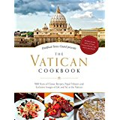](https://www.amazon.com/Vatican-Cookbook-Presented-Pontifical-Swiss/dp/162282332X/ref=sr_1_1?s=books&ie=UTF8&qid=1491272718&sr=1-1&keywords=the+vatican+cookbook)

[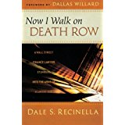](https://www.amazon.com/Now-Walk-Death-Row-Stumbles/dp/0800795059/ref=sr_1_1?s=books&ie=UTF8&qid=1491272365&sr=1-1&keywords=now+i+walk+on+death+row)

[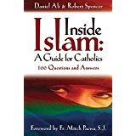](https://www.amazon.com/Inside-Islam-Catholics-Questions-Answers/dp/0965922855/ref=sr_1_1?s=books&ie=UTF8&qid=1491272069&sr=1-1&keywords=inside+islam+a+guide+for+catholics)

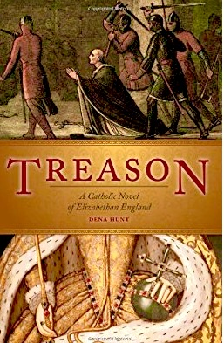

**St. Matthew Parish Library – Recommended Reading**

The Lamb’s Supper by Scott Hahn

**Available in the parish library – NLC 102**

**St. Matthew Parish Library – Recommended Reading**

The Vatican Cookbook by David Geisser and Erwin Niederberger

**Available in the parish library – NLC 102**

**St. Matthew Parish Library – Recommended Reading**

Now I Walk on Death Row by Dale S. Recinella

**Available in the parish library – NLC 102**

**St. Matthew Parish Library – Recommended Reading**

INSIDE ISLAM: A Guide for Catholics by Daniel Ali

**Available in the parish library – NLC 102**