Your ST. MATTHEW PARISH LIBRARY Announces
LIBROS EN ESPAN͊OL!
Spanish Language editions of some of our most popular titles -
these titles, and others, are now located in the “New Arrivals” Display

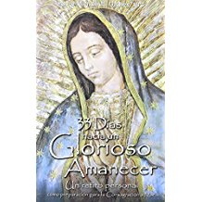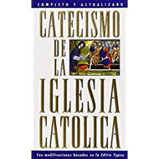
33 Días Hacia Un Glorioso Amanecer Catecismo de la Iglesia Católica
(33 Days to Morning Glory) (Catechism of the Catholic Church)
By Fr Michael E. Gaitley Published by U. S. Catholic Church

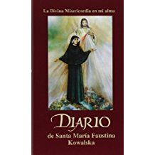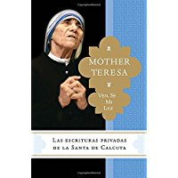
Diario de Santa María Faustina Kowalska Ven, se mi Luz
( Diary of St. Maria Faustina Kowalska) (Come be my Light)
Published by Marian Press By Mother Teresa & Brian Kolodiejchuk

Please Note: All Spanish language books comply with the library’s Collection Policy
and all Spanish titles are also available in the collection in English
Room 102 – New Life Center

