NEW ARRIVALS IN 2017
GENERAL COLLECTION
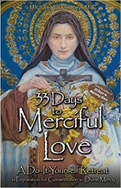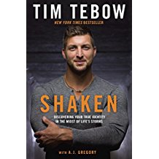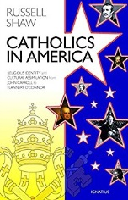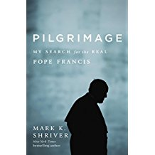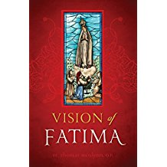

33 Days to Merciful Love: A Do-it-Yourself Retreat in Preparation for
Consecration to Divine Mercy
by Michael Gaitley

Aging Matters: Finding Your Calling for the Rest of Your Life
by R. Paul Stevens

A Pope and a President: John Paul II, Ronald Regan, and the Extraordinary
Untold Story of the 20th Century
by Raul Kengor

BeDADitudes: 8 Ways to Be an Awesome Dad
by Gregory K. Popcak

Catholics and Protestants: What Can We Learn from Each Other?
by Peter Kreeft

Catholics in America: Religious Identity and Cultural Assimilation
from John Carroll to Flannery O’Connor
by Russell Shaw

Catholic Moral Philosophy in Practice and Theory: An Introduction
by Bernard G. Prusak
Discovering God Together
by Dr. Greg Popcak and Lisa Popcak

Exploring the Catholic Church: An Introduction to Catholic Teaching and Practice by Marcellino D’Ambrosio, Ph.D.

Fatima Mysteries: Mary’s Message to the Modern Age
by Grzegorz Gorny

Hard Sayings: A Catholic Approach to Answering Bible Difficulties
by Trent Horn

Hints of Heaven
by Fr. George William Rutler

How to Do Apologetics: Making the Case for Our Faith
by Patrick Madrid

Life Issues, Medical Choices: Questions and Answers for Catholics
by Janet E. Smith

Making All Things New: Catholicity, Cosmology, Consciousness
by Ilia Delio

Mother Angelica Her Grand Silence: The Last Years and Living Legacy
by Raymond Arroyo

Our One Great Act of Fidelity: Waiting for Christ in the Eucharist
by Ronald Rotheiser

Pilgrimage and Exile: Mother Marianne of Moloka’i
by Laurence Hanley

Pilgrimage: My Search for the Real Pope Francis
by Mark K. Shriver

Prayer: Our Deepest Longing
by Ronald Rotheiser

Raising Chaste Catholic Men: Practical Advice, Mom to Mom
by Liela Miller

Sacred Fire: A Vision for a Deeper Human and Christian Maturity
by Ronald Rotheiser

Shaken: Discovering Your True Identity in the Midst of Life’s Storms
by Tim Tebow
Tears of an Innocent God
by Elias Marechal

The Catholic Controversy: A Defense of the Faith
by Francis de Sales
The Catholic Enlightenment: The Forgotten History of a Global Movement
by Ulrich L. Lehner

The Creed: Professing the Faith Through the Ages
by Scott Hahn

The Fatima Prophecies: At the Doorstep of the World
by Dr. Thomas W. Petrisko

The Imitation of the Sacred Heart of Jesus
by Peter J. Amoudt, S.J.

The Light Shines on in the Darkness: Transforming Suffering through Faith (Happiness, Suffering, and Transcendence)
By Robert Spitzer

The Misfit Miracle Girl: Candid Reflections
by Kate Mahoney

The Passion and the Cross
by Ronald Rotheiser

The Power of Silence: Against the Dictatorship of Noise
by Robert Sarah and Nicholas Diat

The Rising Laity: Ecclesial Movements since Vatican II
by Massimo Faggioli

Vision of Fatima
by Dr. Thomas McGlynn

Who Am I To Judge? Responding to Relativism with Logic and Love
by Edward Sri

“Do not let a day go by without some spiritual reading.”
--St. John Bosco

JUVENILE & TEEN
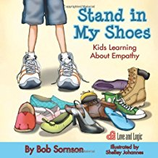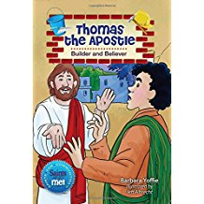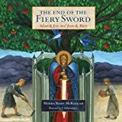

Agnes’ Gift: A heartwarming story about the Power of the Rosary
by Kristelle Angela

A Single Bead
by Stephanie Engelman

Before I Sleep I Say Thank You
by Carol G. Ekster

But It’s Not My Fault
by Julia Cook

Bye-Bye, Bully
by J.S. Jackson

Docat: Catholic Social Teaching for Youth
By Richard Meuser

Francisco and the Hidden Jesus: A True Story (Fatima)
by Marygrace Rose Franz

Genius Under Construction
by Marilee Haynes

I Forgive You: Love We Can Hear, Ask For, and Give
By Nicole Lataif

Jacinta Sacrifices for Sinners: A True Story (Fatima)
by MaryGrace Franz

Little Boys Bible Storybook for Mothers and Sons
by Carolyn Larsen

Love Is All Around North Carolina
by Wendi Silvano

Lucia and Our Lady’s Rosary: A True Story (Fatima)
by Marygrace Rose Franz

Pope Francis Takes the Bus, and Other Unexpected Stories
By Rosario Carello

Search for the Hidden Garden: A Discovery with Saint Therese
by Sherry Weaver Smith

Stand in My Shoes: Kids Learning About Empathy
by Robert Sornson

Thank You, God, For Daddy
By Amy Parker

Thank You, God, For Mommy
By Amy Parker

The Catholic Faith from A to Z
By Sophie de Mullenheim

The End of the Fiery Sword: Adam & Eve and Jesus & Mary
by Maura McKeegan

The Gift of the Christmas Cookie: Sharing the True Meaning of Jesus’ Birth
By Dandi Machall

The Little Flower: A Parable of Saint Therese of Lisieux
By Becky Arganbright

The Wolf and the Shield: An Adventure with St. Patrick
by Sherry Weaver Smith

The Works of Mercy Explained
by Silvia Vecchini

Thomas the Apostle: Builder and Believer (Saints and Me Series)
by Barbara Yoffie

Will Wilder: The Relic of the Perilous Falls
by Raymond Arroyo

DVDs
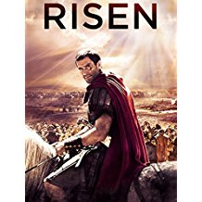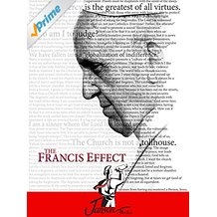

A Case for Christ

Christmas of Many Colors

Eucharist ( Bishop Robert Barron)

Heaven Sent

Lead Kindly Light: The Life and Message of Blessed John Henry Newman

Mary of Nazareth

Risen

Saint Nicholas: The Real Story

The Courageous Heart of Irena Sendler

The Francis Effect

Through the Shadowlands

To Joey With Love

Veggie Tales: A Snoodle’s Tale—Juvenile

Veggie Tales: Growing Confident Kids—Juvenile

Veggie Tales: King George and the Ducky—Juvenile

Veggie Tales: Merry Larry and the True Light of Christmas—Juvenile

