Questions and Answers
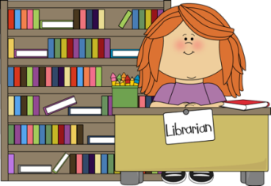
Do I need a library card?
- No, but please legibly fill out a Borrower’s Information Card. A supply of cards is located on the checkout desk.
- Drop the completed Borrower’s Information Card in the blue box on the left side of the desk.
How do I check out an item?
- Locate the checkout card inside the back cover of a book or on the back of a media item.
- Legibly print your name and phone number or parish number on the card.
- Find the current date on the calendar at the front desk. The due date will be written on the calendar.
- Print the due date on the pocket card and also on the pocket attached to the back of the item as a reminder. If you are checking out media, use a post-it note as a reminder of the due date.
- Drop the pocket card in the blue box on the left side of the desk.
How many items can I check out?
- The Juvenile Section has a limit of 5 items per family.
How long can I keep an item?
- Books and media are due two weeks from their checkout date.
Where can I return an item?
- A drop box is located at the corner of the desk.

How can I renew an item?
Please include your name, the title of the item, and the identification number (located on the pocket at the back of the item) when renewing in any of the following ways:
- Call the library at 704-543-7677 Ext. 1019
- Email the library at SMCC_library@stmatthewcatholic.org
- Drop a note in the blue box at the front desk
How can I place a hold on a book?
- Please drop a note into the blue box at the front desk with the pertinent information.
How often is the collection updated?
- Because the collection is constantly changing, it is updated daily.
How can I donate items to the library?
- The library will be happy to accept religious-based books that comply with the mission statement.
- Please put book donations in the boxes provided under the checkout desk.
- Books that are duplicates, worn, or don’t comply with our mission statement will be donated to another source.
How can I recommend a book?
- Send an email with the pertinent information to: SMCC_library@stmatthewcatholic.org
- If the request is approved by the selection committee and the parish staff, it will be added to the purchase list. New items are purchased twice a year—April and August.
I take classes at church. Do you have books/media that would supplement these courses?
- We have a wide variety of books and media that will supplement almost all courses and programs that are offered through the parish.
I have been in the library many times and no one is there to help me. Why not?
- The library is a self-serve, all volunteer ministry. Volunteers are asked to work an hour or two a week, as their schedule permits. Because the library is open every day, from morning to evening, it is not always attended by someone.

Thank you for using the St. Matthew Parish Library!

