Your Parish Library Reaches Out!
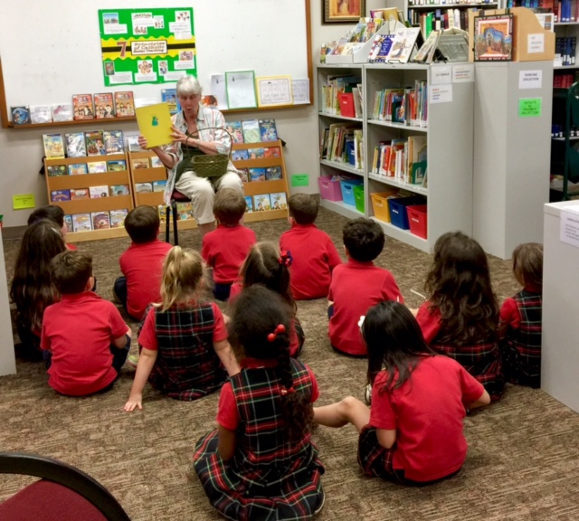
“Story Time With Miss Marie”
Several Transitional Kindergarten (TK) children from St. Matt’s School gather weekly with Miss Marie, a library committee volunteer, to listen to a story chosen by the students. It’s a joy for the children and a joy for Miss Marie as well!
Visit your parish library soon to browse our collection of children’s books and DVDs designed especially for our younger Catholic readers. Mom and Dad will find over 6,000 books and DVDs designed especially for them too!
Room 102 NLC

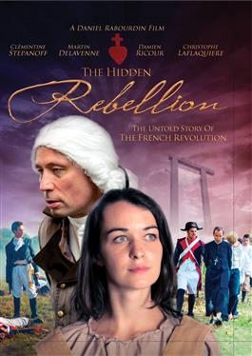
“The Hidden Rebellion: The Untold Story of the French Revolution”
A Daniel Rabourdin Film (For You Joan Productions)
From Ignatius Press: “This powerful docudrama…presents a searing examination of the events and ideas surrounding one of history’s most chilling stories of…the slaughter of the noble Catholics of the Vendee region of France during the French Revolution…an eye-opening picture of this first progressive genocide in the name of ‘social justice’.”
From Your Parish Library Committee: We are very proud to announce that one of our parish library committee members – Dr. Ian Crowe, Adjunct Associate Professor of History at Belmont Abbey College – significantly contributed to the making of this DVD and is featured in several on-screen interviews.
Stop by the Parish Library (Room 102 NLC) and
Check out this or one of our other 400+ DVDs

National Read a Book Day
September 6
Visit the St. Matthew Parish Library and choose from over 6,000 items. New arrivals include:
The Fatima Prophecies: At the Doorstep of the World
by Dr. Thomas W. Petrisko

Shaken: Discovering Your True Identity in the Midst of Life’s Storms
by Tim Tebow

Agnes’ Gift: A Heartwarming Story about the Power of the Rosary
by Kristelle Angela (Teen)

Love is All Around North Carolina by Wendi Silvano (Juvenile)
To Joey With Love (DVD)
Veggie Tales: Growing Confident Kids (Juvenile DVD)

Visit the St. Matthew Parish Library on September 30, the feast day of St. Jerome, Patron Saint of Libraries
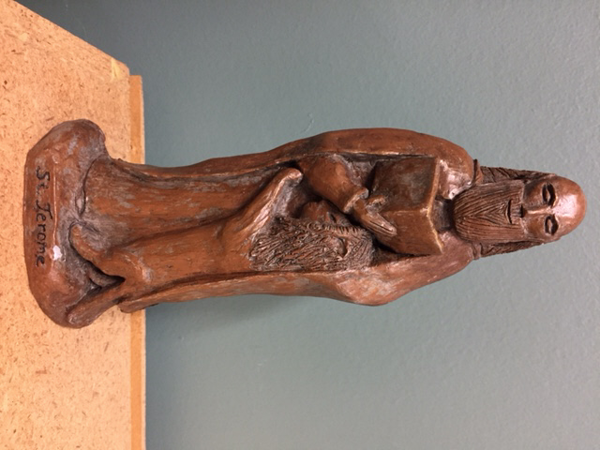
St. Jerome was born in 347 in an area that was part of Italy at the time. He was versed in Latin, Greek, and Hebrew and known as an historian and for his beliefs of Christian moral life. His travels, acquaintances, illnesses and life as a hermit led him to a deeper devotion to God and the Bible.
Jerome was ordained a priest, and then a bishop, worked as secretary to Pope Damasus I, and continued his biblical studies, holding an extensive collection of books. Jerome loved reading, writing, and learning. Of his many writings, his translation of the Bible, the Latin Vulgate, was his most outstanding accomplishment. Jerome founded a monastery in Bethlehem and it was there that he died in 420. His feast day is September 30th.
Artists have portrayed Jerome as a cardinal, even though cardinals didn’t exist at the time, because cardinals were secretaries to the pope. He is sometimes seen with a lion--a belief that he tamed a lion by tending to its paw. Owls, representing wisdom, and writing materials are often included in art work depicting St. Jerome.
Source: Wikipedia

“When we pray we speak to God; but when we read, God speaks to us.”
--St. Jerome

