St. Jerome
Patron Saint of Librarians and Libraries
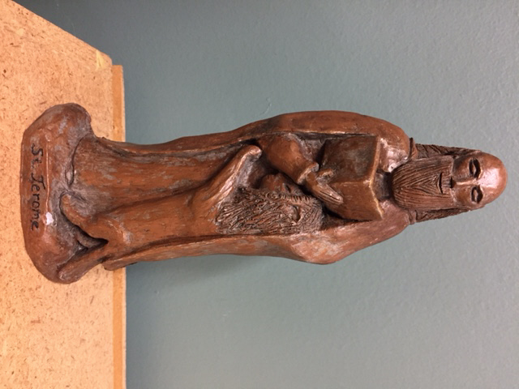
St. Jerome was born in 347 in an area that was part of Italy at the time. He was versed in Latin, Greek, and Hebrew and known as an historian and for his beliefs of Christian moral life. His travels, acquaintances, illnesses and life as a hermit led him to a deeper devotion to God and the Bible.
Jerome was ordained a priest, and then a bishop, worked as secretary to Pope Damasus I, and continued his biblical studies, holding an extensive collection of books. Jerome loved reading, writing, and learning. Of his many writings, his translation of the Bible, the Latin Vulgate, was his most outstanding accomplishment. Jerome founded a monastery in Bethlehem and it was there that he died in 420. His feast day is September 30th.
Artists have portrayed Jerome as a cardinal, even though cardinals didn’t exist at the time, because cardinals were secretaries to the pope. He is sometimes seen with a lion--a belief that he tamed a lion by tending to its paw. Owls, representing wisdom, and writing materials are often included in art work depicting St. Jerome.
Source: Wikipedia

“When we pray we speak to God; but when we read, God speaks to us.”
--St. Jerome

