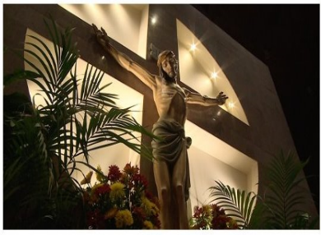 

OFFICE USE:

Check  Cash

Amt: $__________ enclosed

Entered:

 ***Enclose payment with***

***registration and mail to***

**St. Matthew Catholic Church**

**ATTN: Adult FF Registration**

**PO Box 49349**

**Charlotte, NC 28277-0077**

→ ***Write checks payable to:***

*St. Matthew Catholic Church*

→ ***Memo check*** *with class attending.*

St. Matthew “yoU”niversity Registration

**Please Print Clearly**

***Name***

***Email***

***Phone***

***Address***

***City State Zip***

***Parish*** **

***List the courses you are registering.***

***1.***

***2.***

***3.***

***4.***