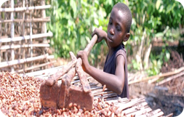
Ethical Shopping to
Combat Slavery &
Promote Creation Care

When we shop are we supporting slavery? Is there destruction to the environment?

It’s a question that is starting to weigh on many of us as we hear more about the prevalence of slavery in our world. Think about the hands that created your clothes or harvested your food. Were they children? Did they suffer? How much pollution and waste was produced in the manufacturing process?

In order to produce goods cheaply and quickly, companies may be giving up ethical and environmental measures to meet the demand for cheaper products. Ethical or Fair Trade represents an employment or trade relationship based on the treatment of workers, artisans and farmers, providing fair wages, safer working conditions and consideration to the community and environment. Fair Trade certification secures the rights of workers, reduces poverty and promotes sustainable development. When consumers choose fair trade or ethically sourced products, they create demand for more products that do not involve child labor and instead support the workers while providing safe and sustainable employment.

These are things we want to consider as conscientious consumers. We have the power to support greater causes through our purchases. Below are ways to shop ethically to support people and the earth.

How to Shop Ethically

READ LABELS. To ensure your product is not made by child labor or slave trade, reading labels can help guide you in seeking ethically sourced products that support the people and the environment where the item originates. Although a number of fair trade certification agencies and standards exist, you can simply google most companies to find out more about their specific standards with respect to the environment and child labor practices even if they are not fair trade certified. Look for the company’s ‘sustainability’ report.
Here are some third-party organization labels that indicate ethical policies are in place:

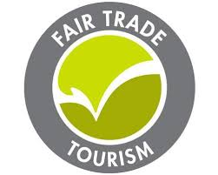
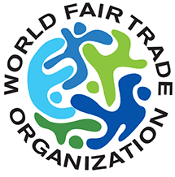
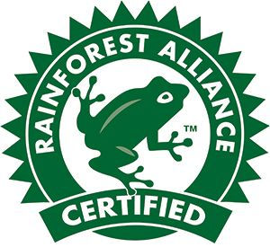
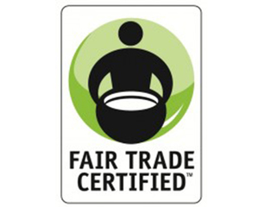

LOOK FOR PRODUCTS MADE BY SURVIVORS

By purchasing items created by victims of violence and human trafficking, you can give survivors a head start on a new life and help them from falling back into the hands of traffickers. Many victims around the world are trafficked or exploited as children and do not have a formal education, so they must build skills and find work to gain sustainable income. Survivors often do this through the creation and sale of hand-crafted goods.

SHOP WITH HELPING ORGANIZATIONS
SERRV International is a nonprofit online store dedicated to fighting global poverty through fair and ethical trade. SERRV employs nearly 8,000 artisans and farmers in 25 countries who are empowered by sustainable employment, fair wages and safe working conditions where they find security and dignity in their work and are able to send their children to school. To learn more about purchasing fair trade items or hosting a fair-trade sale or market at your church or organization, go to: https://www.serrv.org

Educating Your Parish
The Coalition of Catholic Organizations Against Human Trafficking (CCOAHT) resolves to put an end to human trafficking. http://www.usccb.org/about/anti-trafficking-program/coalition-of-catholic-organizations-against-human-trafficking.cfm

The ‘Become A Shepherd’ toolkit PDF is a parish resource guide to educate and provide handouts, literature, prayers, bulletin posts and more on human trafficking. http://www.usccb.org/about/anti-trafficking-program/index
2021 Parish Anti-Trafficking Toolkit CCOAHT Human Trafficking Prevention Month and Day of Prayer Tool Kit

Laudato Si’: On Care of Our Common Home: Free downloadable pdf: (Read online to save paper waste). https://w2.vatican.va/content/dam/francesco/pdf/encyclicals/documents/papa-francesco_20150524_enciclica-laudato-si_en.pdf
Please share on social media or print on recycled paper Image credited to ILRF. https://laborrights.org/ Updated 4/21/2021

