Altar Server Guide 2023
There are 3 server positions at a Mass. The jobs are divided among the three as such:
(1)A - Altar, (2)B - Bells, (3)C– Cross
Directions in black are for two/all servers.
Arrival:
- You must arrive at least 15 minutes before Mass.
- Check in with Mass Coordinator (person with iPad).
- Select an Alb in the correct size.
  - The bottom hem should hang around the top of your shoes.
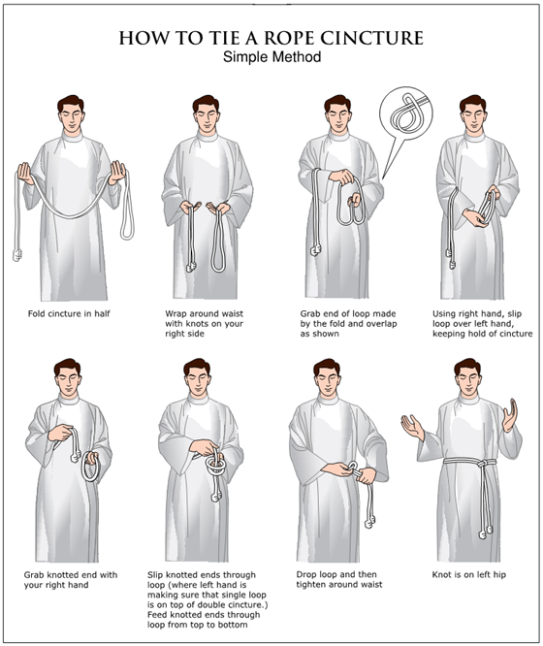
- Select and tie a cincture (rope) around your waist

- Pray the “Altar Server’s Prayer Before Mass” (in the vesting area)
- (3)C: Check if the priest will be using the missal from his chair or at the altar. Get the processional cross and bring it to the back of the church.
- (2)B: check that the bells are in the Sanctuary by your chair.
- Be at the back of the nave at least 5 minutes before Mass.
The Procession:
- (3)C
  - Start the procession when the words to the entrance hymn start.
  - Go to the bottom of the steps, pause briefly, bow your head slightly
  - Walk up the steps and put the cross in its stand.
  - Go behind the sanctuary wall. Stand at credence table with “prayer hands”
and wait.
- (1)A & (2)B
  - Follow when cross bearer is halfway down the first set of pews.
  - Walk side by side. Always walk (or stand) with “prayer hands”
  - Go to the steps and stand 5 feet to the right of center.
  - Stand at the foot of the steps facing the Altar and wait for the clergy.
  - Turn and face the tabernacle and genuflect when they do
  - Step up on the Sanctuary and stand in front of your chair.

Introductory Rites:
- Stand with “prayer hands”
- Say responses & prayers along with congregation
- After the Gloria, (3)C takes Missal to priest at “Let Us Pray”
- Return Missal to the table, go behind the sanctuary wall, and return to chair.

Liturgy of the Word:
- Sit still with your hands in your lap.
- Sing along with the Responsorial Psalm.
- Stand when the Alleluia is sung and while the Gospel is read.
- Be attentive during the homily!
- Stand and pray along with the Creed and Prayers of the Faithful

Preparation of the Gifts:
- (3)C
  - Immediately following the Prayers of the Faithful, take the cross to the back of the church to lead gift bearers.
  - Watch for when the priest comes down the steps – Move when he moves
  - When you reach the priest, walk up the steps to return the cross to its stand.
  - Stand in front of your chair.
- (1)A & (2)B
  - When C moves to go to the back go behind Sanctuary wall together to credence table to assist setting the Altar.
  - Do not place items on the altar yourself – hand them to the deacon or priest from the corner of the altar, then bow slightly with prayer hands once he takes it.
    - Priest’s chalice with linens (always 1st)
    - Ciboria with hosts
    - (if present) Tray with pyx for homebound EMHCs
    - (if present) Paten with low-gluten hosts
  - Assist priest with receiving gifts
  - Wine & water cruets – carry with handles facing out
  - Lavabo (finger bowl) & towel
  - Walk back together behind sanctuary wall to your chair.

Liturgy of the Eucharist:
- While Holy, Holy, Holy is sung, move kneeling pad in front of you.
- Kneel with congregation after Holy, Holy, Holy
- (2)B
  - Quietly move bells so that you can reach them easily.
  - Ring bells ONE time near the beginning of the prayer (epiclesis)
    - Listen for “…these gifts…” OR “…these offerings…”
    - Watch for Priest holding hands flat side-by-side over the chalice
  - Ring bells THREE times during elevation of the bread
    - Listen for “Take this, all of you, and eat of it: for this is my body which will be given up for you.” (then RING)
    - Watch for Priest raising the host
  - Ring bells THREE times during elevation of the bread
    - Listen for “… which will be poured out for you and for many for the forgiveness of sins. Do this in memory of me.” (then RING)
    - Watch for Priest raising the chalice
  - Quietly move bells back out of the way.
- Stand & kneel when the congregation stands & kneels
- Once the priest has received the Body and Blood, stand for receiving Communion
- Sit while the congregation receives Communion.
- When the priest/deacon return to the altar, A & B go behind the sanctuary wall to assist clearing the altar.
  - – Bring cruet of water to priest/deacon
  - Wait & watch for when the priest/deacon finishes with an item. He may hand it to you or direct you to take it from the altar.
  - When you take an item, bow slightly, and then return it to the credence table.
  - Pay attention for when the Eucharist is reposed in the tabernacle – turn towards the tabernacle and genuflect.
  - (2)B – go behind sanctuary wall and sit/stand by chair.
  - (1)A – stay by credence table to hold the Missal for the final blessing (“Let us pray”)

Exit Procession:
- (3)C – When the St. Michael prayer begins, grab the cross and go down the steps. Stand in front of the baptismal font facing the altar.
- A &B – When the St. Michael prayer begins, go down the steps and stand on either side of C facing the altar.
- When the priest bows/genuflects: A & B genuflect, C bows head slightly
- A, B, & C turn immediately turn together and walk to the back of the church.
- When you reach the back, turn together, and face the altar, waiting for the priest.
- Priest / deacon will bow to the cross, saying, “Pro sit” (“May it be of profit to us”)
- Servers respond with “Omnibus et singulis” [OHM-nee-boo-s eht SEEN-gyu-lee-s] (“For all and For each”)

Finishing up:
- (3)C – Once most of the congregation has left, return the cross to the sanctuary.
- Once in the vesting room untie cincture and return it to the bar.
- Take off your Alb and neatly hang it up according to size.
- Highly encouraged: Go into the church and kneel in prayer, thanking God for the opportunity to serve Him during Mass.

Quick Guide
(1)A – Altar
- Follow the cross bearer. Go side-by-side with B
- After the Prayers of the Faithful, move to assist in setting up the altar.
- Help priest with gifts.
- Kneel after the “Holy, Holy, Holy”.
- After the priest drinks from the cup stand to receive Holy Communion.
- Assist after Communion. Cruet of water first.
- Remain at credence table to present book for final prayers
- At St. Michael prayer move to the center aisle with the Cross Bearer, facing the altar
- When the priest turns to the tabernacle and genuflects, you genuflect
- Follow C.

(2)B – Bells
- Follow the cross bearer. Go side-by-side with A
- After the Prayers of the Faithful, move to assist in setting up the altar.
- Help priest with gifts.
- Kneel after the “Holy, Holy, Holy”.
- Ring bells ONE time at epiclesis, THREE times during elevation of the bread & wine
- After the priest drinks from the cup stand to receive Holy Communion.
- At St. Michael prayer move to the center aisle with A & C, facing the altar
- When the priest turns to the tabernacle and genuflects, you genuflect.
- Follow C.

(3)C - Cross
- Get cross 5 minutes before Mass & start walking when the words to the hymn start
- Place Cross in stand and go to credence table to bring Missal to priest
- After the Prayers of the Faithful take cross to the back – lead the Gift Bearers
- Kneel after the “Holy, Holy, Holy”.
- After the priest drinks from the cup, stand to receive Holy Communion.
- At St. Michael prayer get the cross, go to center aisle, facing altar.
- When the priest genuflects turn and lead the procession.

