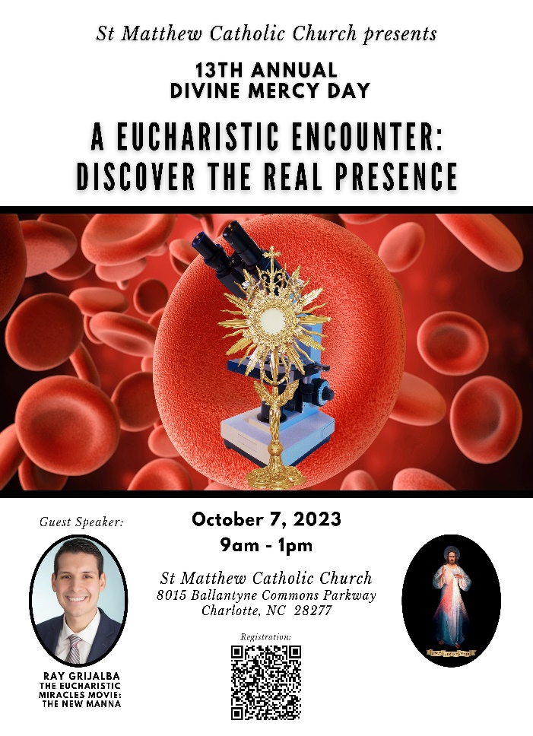

Divine Mercy Day

Follow up Resources:

If there is a QR scan code, please use that, it will take you directly to the publisher’s website.

Otherwise use the provided link to take you directly to the publisher’s webpage for the book.

<https://stmatthewcatholic.org/divine-mercy-day-2023/>

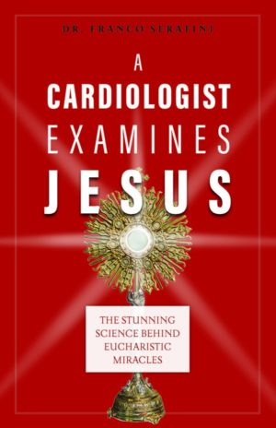 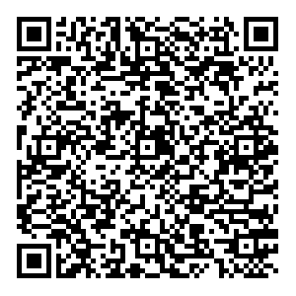

A Cardiologist Examines Jesus - Sophia Institute Press

by [Franco Serafini](https://sophiainstitute.com/contributors/franco-serafini/)   $17.99 USD

<https://sophiainstitute.com/product/a-cardiologist-examines-jesus/>

In this astounding book, prominent cardiologist and author Dr. Franco Serafini walks us through the extensive medical and scientific research into five Eucharistic miracles, unveiling the stunning testimonies of hematologists, oncologists, neurologists, geneticists, molecular biologists, and more who all concluded the same thing: the five Eucharistic miracles are undeniably authentic.

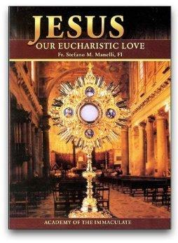 

**Jesus our Eucharistic Love** - Academy of the Immaculate

  by [Fr. Stefano Manelli, F.I.](https://academyoftheimmaculate.com/collections/vendors?q=Fr.%20Stefano%20Manelli%2C%20F.I.)     $5.00 USD

<https://academyoftheimmaculate.com/products/jesus-our-eucharistic-love?>

**A must read to deepen devotion to the Eucharist**

A treasure of Eucharistic devotional writings and examples from the Saints showing their stirring Eucharistic love and devotion. Originally written in Italian, this latest edition is the most complete and accurate English translation. It is the most popular of the Academy of the Immaculate books. A valuable aid for reading meditatively before the Blessed Sacrament.

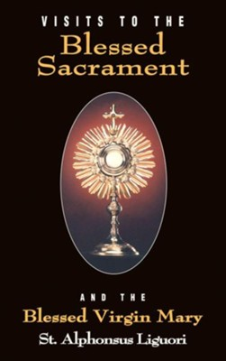   


**Visits To The Blessed Sacrament and the Blessed Virgin Mary** - Tan Books

by [St. Alphonsus Liguori](https://tanbooks.com/authors/st-alphonsus-liguori)

Available formats: Book(paperback) $9.95, ebook $4.95, MP3 Audio Download $9.95

<https://tnbooks.com/products/books/visits-to-the-blessed-sacrament/>

"Here, then, is our heaven on earth—the Most Blessed Sacrament."  
—St. Alphonsus Liguori  
  
This book was conceived and written by the great St. Alphonsus Liguori to help us grow in the knowledge and love of God and in appreciation for what He has done for us. Designed to be prayed in front of the Blessed Sacrament each day over the course of a month, users of this powerful book cannot help but grow closer to Christ.

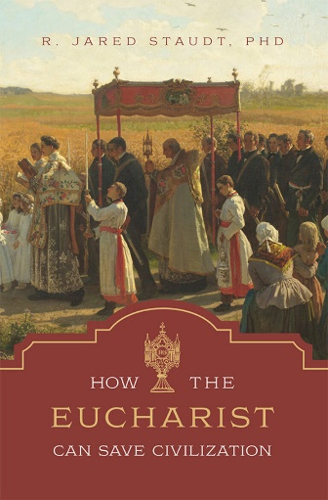



How the Eucharist Can Save Civilization - Tan Books

[by R.Jared Staudt, PHD](https://tanbooks.com/authors/jared-staudt-phd)

 Available formats: Book $32.95 $9.98, ebook, MP3 Audio Download $19.95

<https://tanbooks.com/products/how-the-eucharist-can-save-civilization/>

Watch Video Trailer for Book

<https://www.youtube.com/watch?v=nrZmkz7FcK0>

Christ’s greatest gift, His divine flesh and blood in the Eucharist, is the eternal defining legacy of Christendom, the flower of Western Civilization. The Eucharist is not just a doctrine; it is a reality to be lived, and it must shape our entire lives and culture. Indeed, from hospitals to the great cathedrals, this gift defined Western Civilization and allowed it to reach its highest heights.

Yet now, our Western Civilization verges on complete collapse because we lack this supernatural framework. We have reverted to being barbarians, devoid of a noble vision of human life and the personal cultivation of virtue. But there is a remedy: a return to a Eucharist-centered life.

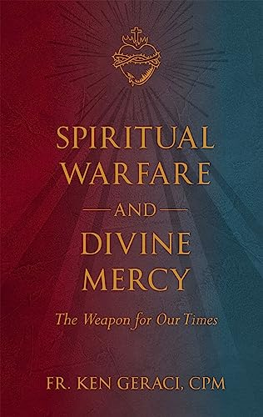

Spiritual Warfare and Divine Mercy: The Weapon for our Times - Tan Books

by [Fr. Ken Geraci, CPM](https://tanbooks.com/authors/fr-ken-geraci-cpm) $27.95 USD

<https://tanbooks.com/products/spiritual-warfare-and-divine-mercy-the-weapon-of-our-times/>

Fr. Ken Geraci takes the reader through a broad overview of spiritual warfare and the development of one’s prayer life, into a powerful encounter with the divine mercy message and the treasury of weapons Jesus gives us through it. **One of the most powerful elements** of his teaching **is the** **opening up of the Divine Mercy Chaplet as an extension of the Liturgy of the Eucharist** and the power and grace that flow from it.

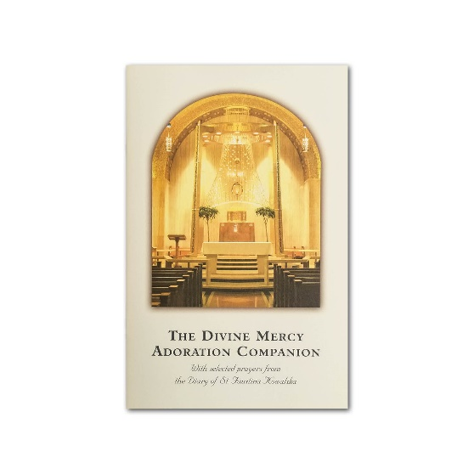

The Divine Mercy Adoration Companion - Divine Mercy for America

$3.95 Booklet

<https://divinemercyforamerica.org/product/store/books/divine-mercy-adoration-companion/>

“Secretary of My most profound mystery. …” the Lord Jesus said to Sr. Faustina, “[Y]our task is to write down everything that I make known to you about My mercy, for the benefit of those who by reading these things will be comforted in their souls and will have the courage to approach Me” (Diary, 1693).

A selection of beautiful prayers and poems from the *Diary* of Saint Faustina along with traditional opening and closing hymns make this booklet a wonderful resource to enrich your prayer time.